Friday 31 July

Dear Students, Parents and Staff

I am writing to you regarding the decision of the government that masks are to be worn by all people over 12 years of age at all times when they leave home. This will mean masks need to be worn by students when coming to school and kept on during the school day and on the journey home.
Simple interpretation from this direction is that students must wear a mask to use the bus, if they are over 12 years of age.
For students to come onto school grounds, if they are over twelve years of age, they need to wear a mask.
A cloth mask will be comfortable and effective.
Each student is responsible for supplying their own mask and wearing it. If you are having difficulty acquiring a mask, a scarf may be used to cover the face.
This is another step that we all must take to help each other. For those of you that did not have a chance to listen to the Premier’s press conference it is attached to help all of us understand our responsibilities to ourselves and others.
I again thank you in advance for your cooperation with this next step which may help us to continue to operate in as normal a manner as possible, looking after ourselves and others within our community.

Regards

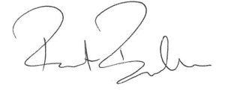
Robert Boucher
Principal

